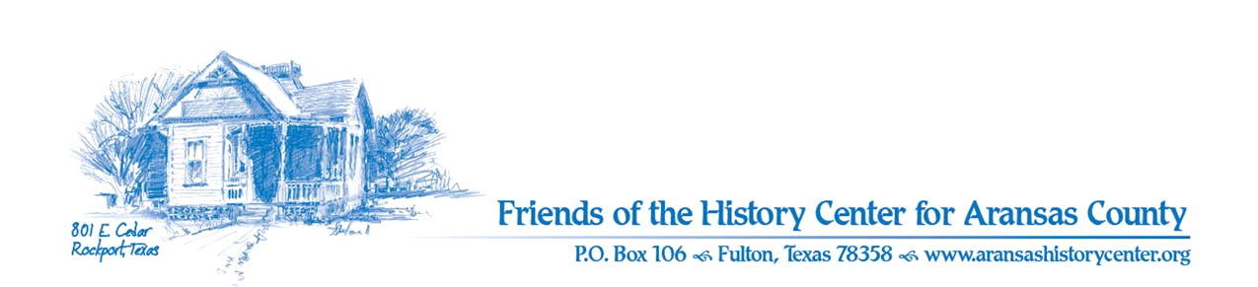Friends of the History Center
Board Meeting Minutes
October 10, 2023
5:30 PM (via Zoom)

Meeting was called to order by Ron Melvin.

No citizens were present.

MINUTES
Pam made a motion to approve September 2023 minutes. Melinda seconded. Motion passed.

TREASURERS’S REPORTS
Melinda:
- Melinda made a motion and Melinda seconded to accept September 2023 treasurer’s report. Motion passed.
- Pam/Ron: we need to look at budget ideas for next year (Melinda will chair).

EXECUTIVE COMMITTEE
Pam:
- Volunteer of the year: Pam suggests Maggie for work in library.
  - Pam made a motion and Ron seconded to approve Maggie. Motion passed.
- Nominating committee for 2023: Melanie, Joe, and Melissa.

DEVELOPMENT
Melinda:
- LAC project –Phase II will not occur due to unforeseen circumstances.
- Grant requests: $5,000 from Barrow Foundation; $15,000 from MS Rust
  - Castaways requested but not presented yet; Rachal and. E. Sams have been submitted.

EDUCATION
Pam:
- Health Care Professionals exhibit: aiming for January opening. Seeking professionals for content.
- Collectors exhibit – successful opening; programs upcoming:
  - Oct. 15, Sun. 2 PM: Black powder guns by Robert Walker & Howard Jones
  - Oct. 28, Sat. 10-3PM: Harbor Haunts at the TMM (FHC table with Maureen Winkelman).
  - Oct. 29, Sun. 2 PM: Archeology & Collectors by David Kroskie, TPWD, & Pam Stranahan, TAS.
- Student outreach: 200 students at Rockport–Fulton Middle School attended.
- Mondays and Wednesdays: Odyssey after school.

FACILITIES
Melanie:
- Kept hummer bird feeders filled (many present).
- Plants were kept watered.
- Pam: Hummer breakfast was successful.

PUBLICITY
Ron:
- Amy has been conducting social media distributions.
- Quarterly report: social media engagement has been very successful, especially due to middle school program.
- Pam: Eric has suggestions for digital outreach (TBD).
- Leslie: seeking permission to share videos of exhibits (Board considers this acceptable).

COLLECTIONS
Pam:
- Cases were prepared for Collectors exhibit.
- Past Perfect entries completed.

OLD BUSINESS
Ron:
- Dec.12 – potluck appreciation event for board and docents at Inn on Fulton Harbor.

NEW BUSINESS
Ron/Pam:
- Form 990 for 2022 has been filed.
- Arbor Week celebrations: tree will be planted at HC (being contributed).
- Since Phase II from Chamber scrubbed, funds needed for desk for Amy.
  - Pam made motion for authorization for Amy to choose desk (up to $500) and use grant funds (ACHC grant) to pay for it. Leslie seconded. Motion passed.
- Leslie would like to plant medicinal herbs at HC; will use local, nonpoisonous plants. Melanie will assist.

Next meeting – November 14, 5:30 PM via Zoom

Melinda made a motion and Melanie seconded to adjourn meeting. Motion passed.

Minutes recorded by Dave Kroskie

Present at meeting:
Ron Melvin
Pam Stranahan
Melinda Gudim
Melanie Konarik
Leslie Albrecht
Dave Kroskie

