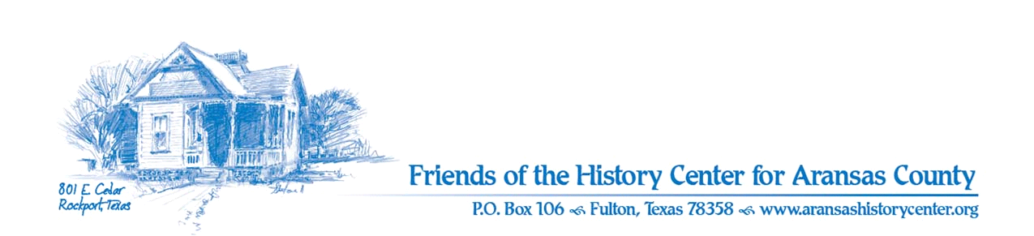Friends of the History Center
Board Meeting Minutes
October 14, 2025
5:30 PM (via Zoom)

Meeting called to order by R. Melvin.

One citizen was present: Pam Stranahan (Pathways Advisory).

Board members present:
D. Kroskie
E. Koenig
J. Fox
M. Gudim
M. Konarik
M. Winkelman
R. Melvin

MINUTES
- M. Winkelman made a motion to approve September 2025 minutes. E. Koenig seconded. Motion passed.

TREASURER’S REPORT
M. Gudim:
- D. Kroskie made a motion to approve September 2025 treasurer’s report. M. Winkelman seconded. Motion passed.

CITIZENS TO BE HEARD
- P. Stranahan:
  - Pathways budget for HC in 2025 is $31,700
  - Pam gave briefing on plans to renovate HC in 2026: budget will be $71,000 (plus the usual $31,000)
  - We need to let Pam know if we need her to do more reporting on projects; she can present plans to the committee
  - All requests or complaints coming from HC should go to Amy or Pam
  - New tourism specialist has been hired for Pathways
  - Consider applying for HOT funding (city hotel occupancy tax funds, not county)

EXECUTIVE COMMITTEE
R. Melvin:
- Reporting on renovations have been ongoing re keeping people informed

FINANCE
M. Gudim:
- Nothing to report

DEVELOPMENT
M. Gudim/R. Melvin (on behalf of D. Griffith):
- More info coming for next board meeting regarding public engagement using Ancestry.com

EDUCATION/EXHIBITS
J. Fox:
- Research phase on new exhibits: Spanish Texas, Texas Revolution; a key is looking for connections between major historical events
- Seeking artifacts for display; we’re exploring various institutions and individuals

FACILITIES
M. Konarik:
- Still having folks come to garden for hummers
- Sidewalks have been appreciated by public per comments

PUBLICITY/MARKETING
E. Koenig:
- Had a spike in website visits during Hummerbird week, but not sure exactly why
- Market Days: will see if there is another bump in website visits
- QR code offers a unique landing page online (one-use); this tells us visitation patterns (event specific)
- Lack of interest in the HC itself, but visitors did seem to be interested in Texas history in general
- He proposes having panels at Market Days with historical information (e.g., mini exhibits); board agrees; can perhaps utilize information from previous exhibits
- Volunteers for Fridays would be appreciated

COLLECTIONS/CURATION
M. Winkelman:
- Items are being moved into pods; movers hired for cases, etc.

OLD BUSINESS
R. Melvin:
- Nomination Committee: two members are ending their first term, E. Koenig and J. Fox, and will need to be renominated
- M. Konarik, J. Fox, and D. Bronner are on committee

NEW BUSINESS
R. Melvin:
- Jan 15th is Winter Texan Appreciation Day
- Need to consider ways to attract people for HC grand opening
- Save the Dates:
  - J. Fox: Armadillo Gang this Saturday 10am to noon at Fulton Mansion (Cemetery Tour)
  - Dec 6th and 7th; need volunteers for the Homes Tour
  - Appreciation Dinner and awards is Dec 9th 530pm
- Next meeting – November 18th at 5:30 via Zoom
M. Gudim made a motion to adjourn the meeting. J. Fox seconded. Motion passed.

Minutes recorded by D. Kroskie

