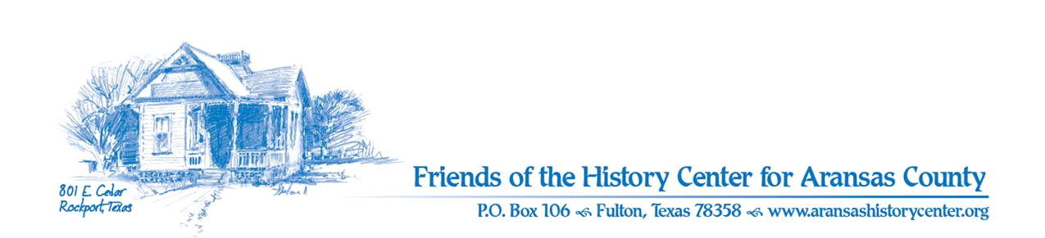Friends of the History Center
Board Meeting Minutes
May 9, 2023
5:00 PM (via Zoom)

Meeting was called to order by Ron Melvin.

No citizens were present.

MINUTES
Melinda made a motion to approve April 2023 minutes. Pam seconded. Motion passed.

TREASURERS’S REPORT (Melinda)
- Pam made a motion and Dave seconded to accept April 2023 treasurer’s report. Motion passed.

EXECUTIVE COMMITTEE
Pam:
- Many inquiries from public; Pam reached out to locals who may be knowledgeable about the various subjects

DEVELOPMENT
Melinda:
- Bookshelves almost done (hopefully next week) for LAC project; requested check from chamber for other items
- Will utilize other funds (from fundraisers) for items for sale
- Business members – Melinda will follow up on prospects
- Application for Coastal Bend Community Foundation is being worked on (will be sent out Friday)
  - Asking for $7,500

EDUCATION
Pam:
- Two new docents
- May 19, 11:30 AM docent training; notice sent to Pilot
- May 20, 10 AM “Our Heritage from the Rage: Ranching & Farming” commencing
  - Goose Island State Park will have activities, plus “old timer” talk and bluegrass music
- September exhibits: being developed
Joe:
- Blackland Museum will donate artifacts for “Our Heritage” exhibit
- Agreed to be narrator for the Cruise; will figure out a date (maybe early June)
- Possible collaboration with THC on some programs/activities (will keep us updated); e.g., for students

FACILITIES
Pam:
- Additional signs put together, just need to be put in
Melinda:
- LAC will come in and help w/ weeding and mulching in garden

PUBLICITY
Ron:
- New card to promote “Our Heritage” exhibit in place
- Lots of interest in fossils exhibit on social media
Pam:
- Sent photos of Connie Hagar for ACHS calendar contest
- Sent small poster for RCA re “Our Heritage” for exhibit set for June
- Possible Fall exhibit – patrons in south Texas

COLLECTIONS
Joe:
- [artifact donations discussed above]

OLD BUSINESS
- Action needed on recruitment (remember to actually ask); Melinda will engage LAC Class

NEW BUSINESS
Pam:
- Rockport City Council meeting tonight; will represent history groups (Historic Preservation Month)
- Next meeting is June 13th at 5:30 PM (via Zoom).
Joe:
- Will inquire about artifacts/materials for next week’s exhibit

Ron made a motion and Joe seconded to adjourn meeting. Motion passed.

Minutes recorded by Dave Kroskie

Present at meeting:
Ron Melvin
Pam Stranahan
Melinda Gudim
Joe Fox
Dave Kroskie

