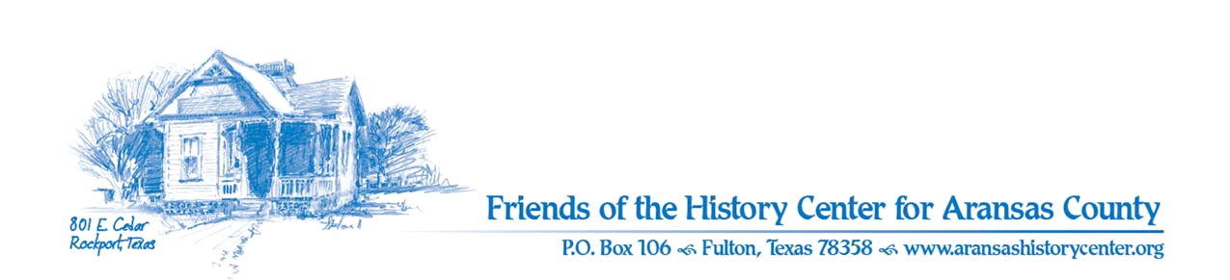Friends of the History Center
Board Meeting Minutes
July 11, 2023
5:30 PM (via Zoom)

Meeting was called to order by Ron Melvin.

No citizens were present.

MINUTES
Pam made a motion to approve June 2023 minutes. Melinda seconded. Motion passed.

TREASURERS’S REPORT
Melinda:
- Pam made a motion and Ron seconded to accept June 2023 treasurer’s report. Motion passed.

EXECUTIVE COMMITTEE
Pam:
- July 24 – will submit quarterly report/presentation to commissioner’s court

DEVELOPMENT
Melinda:
- Library subject plates ordered for bookshelves; LAC meeting tomorrow to go over designs
- Intern will catalog books, and maybe retail space
- Friday meeting regarding grants (to be written and sent out)
- Keep watch out for other grant opportunities

EDUCATION
Pam:
- July 16 – Kayla Butts “Garden to Table” presentation
- July 24 – Joe and Amy working on History Cruise, Monday
- Sept. Collectors & their collections –opening event Sept.30 w/ Wayne White as speaker

FACILITIES
Melanie/Pam:
- Not much activity
- Hummingbird prep
- Pathways has been irrigating, but need to keep an eye on it per the heat
- Police requesting a permit to security system (is on file; we’re clear)

PUBLICITY
Ron:
- Lots of communication via social media, flyers for Our Heritage exhibit, Passport 4 Past updates

COLLECTIONS
Ron/Pam:
- Nothing to report

OLD BUSINESS
- Intern was approved by Board
- Pam made a motion to accept intern (Jae Williams). Melinda seconded. Motion passed.

NEW BUSINESS (Ron)
- Appreciation event needed for board and docents
- Probably best to wait until December, maybe Inn at Fulton Harbor or private residence

Next meeting – September 12, 5:30 PM – ZOOM

Melanie made a motion and Ron seconded to adjourn meeting. Motion passed.

Minutes recorded by Dave Kroskie

Present at meeting:
Ron Melvin
Pam Stranahan
Melinda Gudim
Melanie Konarik
Dave Kroskie

