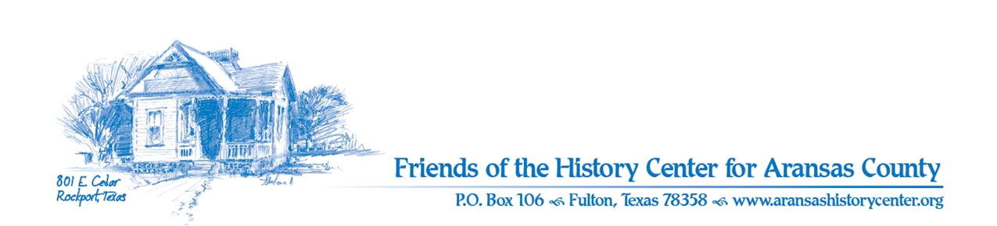Friends of the History Center
Board Meeting Minutes
Feb 14, 2023
5:30 PM (via Zoom)

Meeting was called to order by Ron Melvin

No citizens were present.

MINUTES
Pam made a motion to approve Jan. 2023 minutes. Melanie seconded. Motion passed.

TREASURERS’S REPORT
Melanie made a motion and Pam seconded to accept Jan. 2023 treasurer’s report. Motion passed.

EXECUTIVE COMMITTEE
Ron:
- Signature cards (see further discussion in New Business below)

Pam:
- Previous quilting program had 18 to 20 visitors.
- March 12: program on how to do fabric painting on quilts.
- Commissioner’s report for Oct, Nov, and Dec presented by Pam; went well.
- Feb 18th: Woman’s Club having a luncheon for 75th anniversary, FOC invited.

DEVELOPMENT
Melinda:
- Will have new individual members, but no business members at this time.
- Grant received from Castaways for $3,000.00.
- This Saturday will be a fundraiser at various local bars, anticipated to be successful.

EDUCATION
Pam:
- History cruise set up for March 29^{th.}
- April 15th student art exhibit; submissions due April 1st.
- Zoom committee meeting for “Our Heritage from the Range: Ranching and Farming” exhibit; members have been drafted for completing posters.

FACILITIES
Melanie:
- Hummingbird feeders ready; anticipating birds in mid-March.
- Plant ID signs in garden will be ordered; hopefully plants will grow back from freeze.

Pam and Ron:
- Motion by Melinda for funding plant ID signs. Ron seconded. Motion passed.
- New bench ordered; will be a celebration.

PUBLICITY
Ron:
- Attractions Committee at HC on April 13th
- Pam is on front page of the Pilot.

COLLECTIONS
Joe and Pam:
- Art teacher contacted for prep on art exhibit.
- Local ISD hopefully will provide intern.

OLD BUSINESS
[No old business to discuss]

NEW BUSINESS
Ron:
- Corporate banking resolution for Prosperity; paperwork for new signature cards:
  - Maureen Winkelman and John Bemrose have been removed from the signature card for 2023; Ron Melvin, Amy Parker, Pam Stranahan, and Melinda Gudim are now the signatories.
  - Motion made by Ron. Melinda seconded. Motion passed.

- Next meeting is March 14th at 5:30 PM (via Zoom).

Meeting adjourned.

Minutes recorded by Dave Kroskie

Present at meeting:
Pam Stranahan
Dave Kroskie
Ron Melvin
Melinda Gudim
Melanie Konarik
Joe Fox

