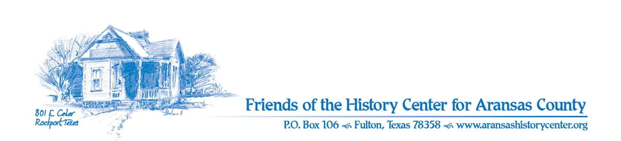Friends of the History Center
Board Meeting Minutes
June 13, 2023
5:30 PM (via Zoom)

Meeting was called to order by Ron Melvin.

No citizens were present.

MINUTES
Pam made a motion to approve May 2023 minutes. Dave seconded. Motion passed.

TREASURERS’S REPORT (Ron)
- Pam made a motion and Dave seconded to accept May 2023 treasurer’s report. Motion passed.

EXECUTIVE COMMITTEE
Ron/Pam/Joe:
- Letters of appreciation are being sent to business members for their contributions
- LAC dinner – attended by Joe

DEVELOPMENT
Pam:
- Grants – July: MS Rust, Rachal; Sept.: E. Sams, Barrow
  - still working towards these; currently crafting proposals for submission
  - consider reaching out to Randy Bissell

EDUCATION
Joe/Ron/Pam:
- Sheep Ranching went well; good feedback
- July 16 – Kayla Butts: Garden to Table Cookbook (organic farming)
- June/July - Joe and Amy working on a History Cruise date; still need to establish
- Education committee – need to set up a meeting, primarily re Collector’s exhibit, also to think of any celebrities who may want to show off collections; Joe is doing some research and will let us know; possibly Judge Mills? Judge Garza?
- Joe: Junior Historians (and/or Armadillo Gang) – Joe is reaching out to museums for programs, has an outline, and is getting support
  - Pam: HC should give financial support to the group - $500 for field trips will be a line item in new budget. Pam made a motion, Joe seconded. Motion passed.

FACILITIES
Pam:
- Cindy Cox to have gardens ready for May 20 opening; mulch by LAC.
- Visit to HC by Rene Butler – county will replace HVAC for garage, repair ramp, and work to make pathways ADA.
  - Pathways will pay for it (managed by county)

PUBLICITY
Pam:
- Overall promotion includes media distribution, postcard invitation, ads, and social media
- Chamber is doing welcome bags (Amy is developing rack cards)
- Chamber promo basket for June event is complete
- Chamber auction – we get publicity out of it
- Thursday Pam will have interview with Victoria KAVU News, will discuss press release about article for Pathways, local history sites, and HC

COLLECTIONS
Joe:
- Ranching exhibit items donated by Blacklands Museum have been procured

OLD BUSINESS
- Education Committee meeting re Collectors exhibit will be Tuesday the 27th at 5:30pm via Zoom

NEW BUSINESS
- Nothing to report

NEXT MEETING – July 11 at 5:30pm via Zoom

Ron made a motion and Pam seconded to adjourn meeting. Motion passed.

Minutes recorded by Dave Kroskie

Present at meeting:
Ron Melvin
Pam Stranahan
Joe Fox
Dave Kroskie

