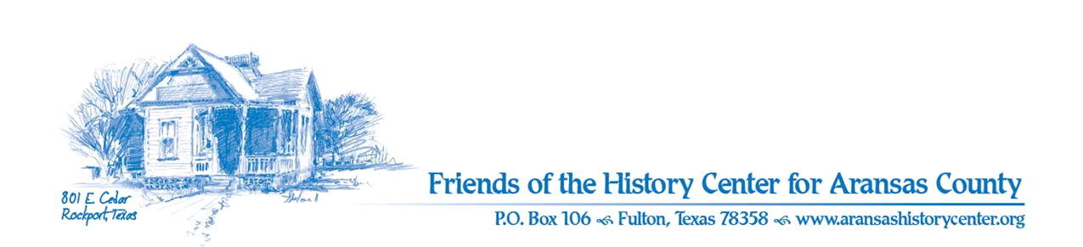Friends of the History Center
Board Meeting Minutes
January 9, 2024
5:30 PM (via Zoom)

Meeting was called to order by Ron Melvin.

No citizens were present.

MINUTES
Pam made a motion to approve November 2023 minutes (there was no December meeting). Melinda seconded. Motion passed.

TREASURERS’S REPORTS
Melinda/Ron:
- Leslie made a motion and Pam seconded to accept November/December 2023 treasurer’s report. Motion passed.
- Draft 2024 budget has been presented and approved.
- Pam: payroll – Need more funding for administration to be sustainable; perhaps can create endowment; memberships – perhaps create committee to get more business memberships.
- Consider gift basket for Gary Cole to thank for submitting Q reports.

EXECUTIVE COMMITTEE
Ron/Pam:
- Bridget Trevino is the new coordinator for Aransas Pathways, with increased emphasis on marketing.

DEVELOPMENT
Melinda:
- Memberships – we will participate in Winter Texas event and engage businesses and individuals.
- Rachel Foundation – we’ve turned in request and are awaiting response.

EDUCATION
Pam:
- Dec. 2–29: “Historical Holiday” – very well-received.
- Jan. 20: – “Healing Hands: Healthcare in Ar. Co.” opening; docent preview on Jan. 19.
  - Descendants of Roaten and Johnson will be available for discussion on opening.
  - Will consider putting on Facebook Live.
- Program invitation postcards have been sent out.
- Pam will also advertise at several public talks.

FACILITIES
Melanie/Pam:
- Gift shop reorganized; consider any new additions needed.
- Floors will be repaired before next exhibit.
- Paths have gotten new surfaces.

PUBLICITY
Ron:
- Promotions via Amy have received much attention on social media.

COLLECTIONS
Pam:
- Public was active in contributing artifacts for Healing Hands exhibit.

OLD BUSINESS
Ron:
- Nothing to report.

NEW BUSINESS
Melanie:
- Election of 2024 officers – all current officers will continue to serve. Leslie made a motion and Melinda seconded to accept the slate presented. Motion passed.
  - President: Ron Melvin, Vice President: Pam Stranahan, Secretary: Dave Kroskie, Treasurer: Melinda Garrett Gudim
- Standing Committees members will remain the same for 2024.

Next meeting – February 13th at 5:30 via Zoom.

Melinda made a motion and Pam seconded to adjourn meeting. Motion passed.

Minutes recorded by Dave Kroskie

Present at meeting:
Ron Melvin
Pam Stranahan
Melanie Konarik
Melinda Gudim
Eric Koenig
Leslie Albrecht
Dave Kroskie

