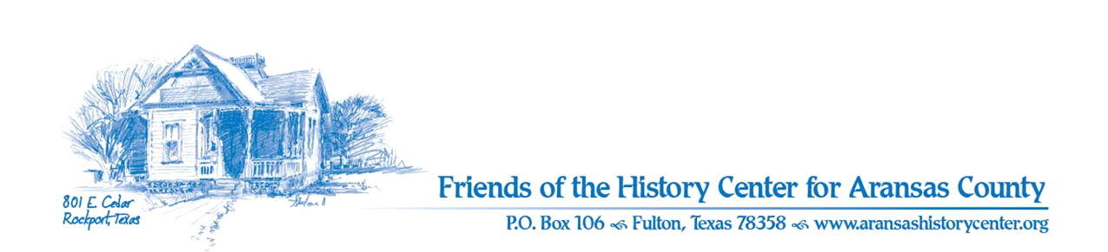Friends of the History Center
Board Meeting Minutes
March 14, 2023
5:30 PM (via Zoom)

Meeting was called to order by Ron Melvin.

No citizens were present.

MINUTES
Melinda made a motion to approve Feb. 2023 minutes. Pam seconded. Motion passed.

TREASURERS’S REPORT
Pam made a motion and Dave seconded to accept Jan. 2023 treasurer’s report. Motion passed.

EXECUTIVE COMMITTEE
Ron:
- Father Tung has resigned. Resignation accepted as written and will be removed from the board.
- Need suggestions for new board members.

Pam:
- Tropical Trails will be March 21st at HC; several venues will be visited. Pam will do Voices of the Past presentation.
- Last Sunday’s program – about 15 people attended. Went well.

DEVELOPMENT
Melinda:
- Per representative for Raymond James: $60,000 is not worth it to invest in treasury bills (due to fees and commissions). Better off going with a CD through local Prosperity Bank. Ron made a motion to rescind Raymond James resolution, and HC will purchase a CD through Prosperity for $60,000 over 7 months. Pam seconded. Melinda will handle the account as specified in last month’s minutes.
- Memberships: no new business memberships, but leadership class of Aransas County (LAC) is coming to HC in April and Melinda will discuss memberships with them.
- Made $13,000 at Poker Run (covers Phase 1 of purchases for HC).
- This coming weekend: crawfish boil; proceeds will go towards Phase 2.
- [Pam] Coastal Bend Community Foundation: she will ask for donations for future exhibits.

EDUCATION
Pam:
- History Cruise has sold out (with waiting list).
- Exhibits:
  - April 15th student art exhibit; submissions due April 1st
  - Upcoming fossil exhibit will run concurrent with student art exhibit; fossils plus a poster have been procured; Pam did research and wrote additional 6 posters.
  - Ranching and Farming: speakers have been lined up of several locals involved in local ranching.
  - Chamber of Commerce reached out to HC about Hurricane Harvey exhibit “Rock Solid” to see if we want it (as a donation). Agreed that we should take it. Pam made motion to accept and Melinda seconded. Motion passed.

FACILITIES
Pam:
- County Maintenance Dept. will take over maintenance that Pathways has been doing.

PUBLICITY
Ron:
- Attended THC presentation about social media best practices; it seems we are on the right track.
- Pam on front page of the Pilot for Preservation Awards; Dave also included for upcoming Voices from the Past presentation.
- [Pam] the Rotary has been provided auction items.
- [Pam] Preservation Awards: we need someone to serve on committee; meetings will be Mar 20th and April 10.

COLLECTIONS
Ron and Pam:
- Still looking for an intern from a local ISD.

OLD BUSINESS
[No old business to discuss]

NEW BUSINESS
Ron:
- One new docent, but more needed.
- Next meeting is April 11th at 5:30 PM (via Zoom).

Meeting adjourned.

Minutes recorded by Dave Kroskie

Present at meeting:
Ron Melvin
Pam Stranahan
Melinda Gudim
Dave Kroskie

