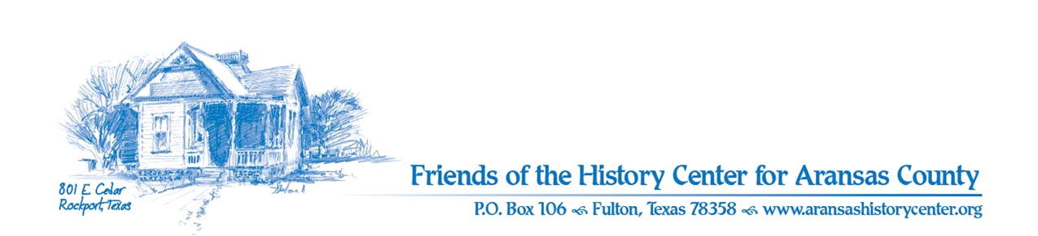Friends of the History Center
Board Meeting Minutes
April 11, 2023
5:30 PM (via Zoom)

Meeting was called to order by Ron Melvin.

No citizens were present.

MINUTES
Pam made a motion to approve March 2023 minutes. Melinda seconded. Motion passed.

TREASURERS’S REPORT
Melinda:
- Melinda made a motion and Ron seconded to accept March 2023 treasurer’s report. Motion passed.
- Melinda needs signed copy with date of March minutes from Dave. Noted and will do.

EXECUTIVE COMMITTEE
Pam:
- Will give report to Commissioner’s Court re 1st quarter.
- Is keeping in contact with Keep Aransas Beautiful.
- Passport seems to be active, just not too many visitors at HC.

DEVELOPMENT
Melinda:
- Coastal Bend Community Foundation: she will coordinate w/ Pam re grants (due May 1).
  - Need a plan for 2024 (tentative topics, e.g., items on April agenda discussed, plus Ron mentioned idea of highlighting the various events/festivals that have been important to the community).
  - Tentatively agreed to health care, ghost towns of Copano Bay, and events/festivals.

EDUCATION
Pam:
- Cruise went well.
- April 13, 11:30 AM: docent training for Art and Fossils.
- April 15. 10 AM: Exhibits: Student Art Celebrating History, awards and Fossils display will be open.
- April 22, 10 AM: hands-on demonstration by Randy Bissell.
- May 20: “Our Heritage from the Range: Ranching & Farming” – participants need to submit posters by 4/17/23.
- MoM:
  - partner with Museum on Main St. (MoM) for exhibit from Smithsonian Heritage – Amy is organizing activities.
  - exhibit is about rural communities moving from farms to cities (“crossroads”); need to find location; can possibly use “Our Heritage from the Range” posters.
- Ron made motion and Pam seconded to pursue participating in the exhibit. Motion passed.

FACILITIES
Ron and Pam:
- Additional signs (per agenda).
- Garden event should be set up (celebrate new bench and signage).
- Ross family donated $500.
- Renee Butler overseeing maintenance.

Melinda:
- New library is basically built and will receive final touches.
- Need to schedule a day for LAC Class to come and help prep for install.

PUBLICITY
Ron:
- Pilot ,etc. has been effective.
- Pam did Happy Hour at Fulton Mansion.
- Melinda will host LAC Class at HC on 4/12/23.
- Amy: Chamber attractions 4/13/23.

COLLECTIONS
Joe and Pam:
- Still looking for an intern from a local ISD, but Maggie Eckhoff will be trained and will assist.

OLD BUSINESS
- Action needed on recruitment; Melinda will engage LAC Class; maybe “Voices” can be used to recruit.

NEW BUSINESS
Ron:
- Continue to develop 2024 plan for exhibits
- Next meeting is May 9th at 5:30 PM (via Zoom).

Meeting adjourned.

Minutes recorded by Dave Kroskie

Present at meeting:
Ron Melvin
Pam Stranahan
Melinda Gudim
Joe Fox
Dave Kroskie

